ENTERPRISE INFRASTRUCTURE PLAN
ABC Startup Solutions
IT Infrastructure Planning for a Newly Established Startup Company
Prepared for: Company Management / IT Manager
Prepared by: Kurt Andrew C. Ramos
Role: Junior System Administrator
ITEP 414 - System Administration and Maintenance
Week 2 Portfolio Project | Bachelor of Science in Information Technology
Laguna State Polytechnic University

Part 1 — Company Profile

Company Overview
Field | Details
Company Name | ABC Startup Solutions
Nature of Business | Custom software development and IT consulting for small and medium enterprises (web applications, mobile applications, and cloud-based business systems)
Office Location | 4th Floor, TechHub Building, Greenfield Business Park, Los Baños, Laguna, Philippines (fictional)
Company Size | 20 employees, single office floor
Date Established | January 2026 (fictional)

Company Vision
To become a leading software solutions provider in the Philippines and Southeast Asia, recognized for delivering reliable, secure, and innovative technology that empowers businesses of every size to grow in the digital economy.

Company Mission
ABC Startup Solutions is committed to designing and delivering high-quality, scalable, and secure software solutions through a culture of continuous learning, technical excellence, and strong client partnerships, while building a solid and well-managed IT infrastructure that supports sustainable business growth.

Organizational Structure
ABC Startup Solutions follows a flat, functional organizational structure appropriate for a 20-person startup. The Chief Executive Officer oversees four department heads, each responsible for a functional area of the business. The Junior System Administrator reports to the IT Manager and is responsible for infrastructure planning, deployment, and day-to-day technical support across all departments.
- Chief Executive Officer (CEO)
- IT Manager → IT Department (Junior System Administrator, Developers, Helpdesk staff)
- HR Manager → Human Resources Department
- Finance Manager → Finance Department
- Sales Manager → Sales Department

Employee Distribution
Department | Employees | Primary Function
Information Technology | 5 | Software development, infrastructure, and technical support
Human Resources | 4 | Recruitment, employee relations, payroll coordination
Finance | 5 | Budgeting, billing, financial reporting
Sales | 6 | Client acquisition, account management, business development
TOTAL | 20

Part 2 — Enterprise Hardware Inventory
The hardware inventory below covers every employee workstation as well as the shared infrastructure equipment needed to support day-to-day operations across all four departments. Desktop computers are assigned to roles that work primarily from fixed stations (HR, Finance), while laptops are assigned to roles that require mobility (IT/Development, Sales).
Asset ID | Hardware | Quantity | Department | Purpose
HW-001 | Desktop Computer | 9 | HR (4), Finance (5) | Office productivity, HR records, financial processing at fixed workstations
HW-002 | Laptop | 11 | IT (5), Sales (6) | Portable development work and on-site/off-site client sales visits
HW-003 | Server (Tower) | 1 | IT / Shared | Hosts internal applications, file sharing, Git repository, and Ubuntu Server workloads
HW-004 | Router | 1 | Shared (all depts) | Routes traffic between the LAN and the ISP connection
HW-005 | Switch (24-port) | 1 | Shared (all depts) | Provides wired connectivity for all workstations and devices
HW-006 | Printer | 2 | Shared (Admin area, Sales/Finance area) | Shared network printing for documents, invoices, and reports
HW-007 | UPS (1500VA) | 3 | Server Room (1), Network Rack (1), Finance (1) | Prevents data loss and equipment damage during power interruptions
HW-008 | Wireless Access Point | 2 | Shared (all depts) | Extends network coverage across the single office floor
HW-009 | NAS Storage (4-Bay, 8TB) | 1 | IT / Shared | Centralized file storage and scheduled backup target
HW-010 | External Backup Drive (4TB) | 2 | IT (offsite rotation) | Weekly offsite backup rotation for disaster recovery
HW-011 | Monitor (24-inch) | 20 | All Departments | Display unit for every desktop and laptop user

Justification of Selections
- Desktops for HR and Finance: these roles work from fixed desks and handle sensitive records best kept on stationary, easier-to-secure hardware.
- Laptops for IT and Sales: developers benefit from portability for testing and pair work; the sales team needs laptops for client visits and off-site presentations.
- A single physical server is sufficient at this scale (20 users) and can be virtualized later as the company grows.
- Two printers avoid a single point of failure and reduce walking distance between the admin area and the finance/sales area.
- Three UPS units protect the server, network rack, and finance workstations, since these are the most disruption-sensitive points.
- An NAS separate from the main server ensures backups are not lost if the server itself fails.

Part 3 — Enterprise Software Inventory
The software stack below balances free/open-source tools for development work with licensed productivity and security software for general business use.
Software | Version | License | Purpose
Windows 11 Pro | 23H2 | Volume License (per device) | Primary desktop/laptop operating system for all non-IT staff
Ubuntu Server | 22.04 LTS | Free / Open Source | Operating system for the internal application and file server
Microsoft Office | Microsoft 365 Business Standard | Subscription (per user) | Word processing, spreadsheets, email, and presentations for all departments
VS Code | 1.9x (latest) | Free | Primary code editor for the IT/development team
Git | 2.44 | Free / Open Source | Source control for all software projects
GitHub Desktop | 3.3 | Free | Graphical interface for managing Git repositories
VirtualBox | 7.0 | Free / Open Source | Virtual machines for testing, staging, and training environments
Google Chrome | Latest stable | Free | Standard web browser for all employees
Microsoft Defender | Built-in (Windows) | Included with Windows 11 Pro | Baseline endpoint antivirus and threat protection
AnyDesk | Latest | Business License | Remote support and troubleshooting by the IT/Helpdesk team
7-Zip | 23.01 | Free / Open Source | File compression and archive management

Part 4 — Enterprise Network Inventory
The following networking equipment supports a single-floor office of 20 users with wired connectivity for fixed workstations and wireless coverage for laptops.
Asset ID | Equipment | Quantity | Specification | Purpose
NW-001 | ISP Modem | 1 | Fiber modem, up to 300 Mbps | Terminates the ISP fiber line into the office
NW-002 | Router | 1 | Dual-WAN capable, Gigabit ports | Provides routing, NAT, and DHCP for the LAN
NW-003 | Firewall | 1 | UTM firewall appliance | Filters inbound/outbound traffic, VPN termination, intrusion prevention
NW-004 | Switch (Core, 24-port) | 1 | Gigabit managed switch | Central wired connectivity point for all departments
NW-005 | Wireless Access Point | 2 | Wi-Fi 6, dual-band | Wireless coverage for laptops and mobile devices
NW-006 | Patch Panel (24-port) | 1 | CAT6 rated | Organizes and terminates horizontal cabling in the server rack
NW-007 | CAT6 Cable | 300 m (spool) | 23 AWG, UTP | Structured cabling from patch panel to wall outlets/workstations
NW-008 | RJ45 Connector | 100 pcs | CAT6 rated | Termination of CAT6 cable runs and patch cords

Part 5 — Enterprise Network Diagram
The diagram below illustrates the logical network topology for ABC Startup Solutions, from the internet connection down to each department's LAN segment. It was designed to mirror a professional draw.io-style topology and is provided as embedded artwork below, with PNG and PDF export files included in the project repository's /diagrams folder.
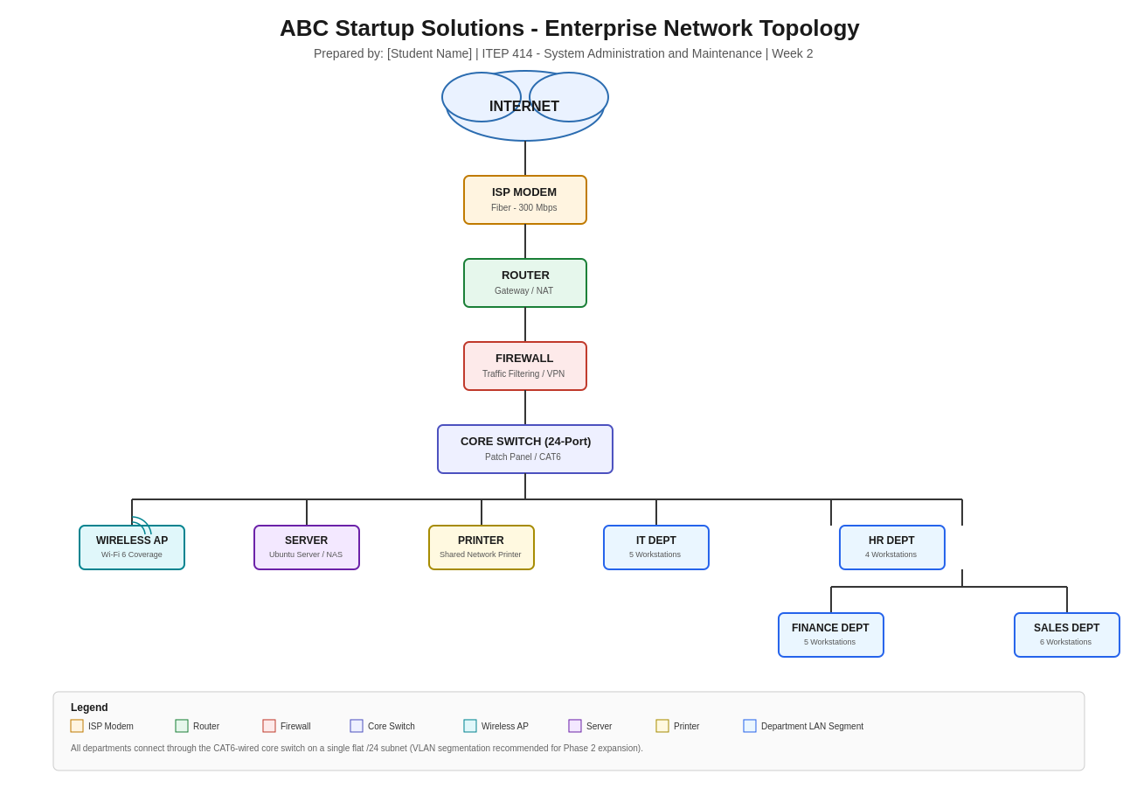

Traffic flows from the Internet through the ISP modem into the router, which hands off to a dedicated firewall for filtering and VPN termination. The firewall connects to a core switch that fans out, via CAT6 structured cabling and a patch panel, to the wireless access points, the server, the shared printer, and each department's workstations. All departments currently share a single flat subnet; VLAN segmentation is recommended as a future enhancement (see Part 7).

Part 6 — System Administration Roles
Helpdesk Technician
Responsibilities: Serves as the first point of contact for end-user issues; logs and resolves hardware, software, account, and connectivity tickets; escalates complex issues to senior IT staff; performs basic hardware setup and maintenance.
Skills: Troubleshooting, customer service, basic networking, operating system fundamentals, ticketing workflows.
Common Tools: Ticketing systems (e.g., Freshservice, Zendesk), Remote support software (AnyDesk, TeamViewer), Active Directory basics.
Certifications: CompTIA A+, ITIL Foundation.
Network Administrator
Responsibilities: Designs, configures, and maintains routers, switches, firewalls, and wireless access points; monitors network performance and uptime; manages IP addressing, VLANs, and VPN access; enforces network security policy.
Skills: Routing and switching, subnetting, firewall configuration, network monitoring, troubleshooting.
Common Tools: Wireshark, PRTG/Zabbix, Cisco Packet Tracer, pfSense/firewall consoles.
Certifications: CompTIA Network+, Cisco CCNA.
Linux System Administrator
Responsibilities: Installs, configures, and maintains Linux servers; manages users, permissions, and services; automates routine tasks with shell scripts; monitors system logs and performance; applies patches and security updates.
Skills: Linux command line, shell scripting (Bash), service and process management, package management, backups.
Common Tools: SSH, cron, systemd, Bash, Ansible (basic automation).
Certifications: CompTIA Linux+, RHCSA (Red Hat Certified System Administrator).
Cloud Administrator
Responsibilities: Provisions and manages cloud resources (compute, storage, networking); monitors cloud costs and usage; implements cloud backup and disaster recovery; manages identity and access for cloud services.
Skills: Cloud platform fundamentals (IaaS/PaaS), virtual networking, identity and access management, cost optimization.
Common Tools: AWS/Azure/Google Cloud console, Terraform (infrastructure as code), cloud monitoring dashboards.
Certifications: AWS Certified Cloud Practitioner, Microsoft Azure Fundamentals (AZ-900).

How These Roles Work Together
In a growing organization like ABC Startup Solutions, these four roles form a layered support structure that keeps the infrastructure running smoothly. The Helpdesk Technician handles the day-to-day, front-line issues employees encounter and filters out routine problems before they reach senior staff. When an issue is network-related — a slow connection, a misconfigured access point, a VPN failure — it is escalated to the Network Administrator, who manages the physical and logical network described in Part 5. The Linux System Administrator keeps the backend server environment (Ubuntu Server, internal applications, file sharing) healthy, secure, and backed up, working closely with the Network Administrator since server access depends on a stable network. As the company scales and begins adopting cloud services for redundancy or remote collaboration, the Cloud Administrator extends this same discipline to cloud-hosted resources, ensuring consistency between on-premises and cloud environments. Together, these four roles cover the full stack of enterprise IT — client-facing support, network infrastructure, server administration, and cloud operations — and typically coordinate through shared ticketing systems and regular hand-offs so that no layer of the infrastructure is left unmonitored.

Part 7 — Infrastructure Recommendations

Internet Provider
A business-grade fiber connection (minimum 300 Mbps symmetrical) from a nationally established ISP is recommended, paired with a secondary backup connection (e.g., a 5G/LTE failover router) so that connectivity does not become a single point of failure for a company that depends on always-on client access to hosted applications.

Server Specifications
A single rack-mountable or tower server is sufficient at 20 employees: a multi-core processor (8+ cores), 32-64 GB RAM, RAID-1 or RAID-5 storage for redundancy, and dual power supplies if budget allows. Running Ubuntu Server LTS keeps licensing costs low while providing long-term support and stability. As the company grows, this server can be virtualized (e.g., with Proxmox or VMware) to host multiple isolated workloads.

Backup Strategy
A 3-2-1 backup approach is recommended: at least three copies of critical data, stored on two different types of media, with one copy kept offsite. In practice this means nightly automated backups from the server to the NAS, weekly rotation to the external backup drives, and monthly offsite/cloud backup storage. Backup restoration should be tested quarterly to confirm the backups are actually recoverable.

Security Recommendations
- Segment the network into VLANs per department to limit lateral movement if one workstation is compromised.
- Enable the firewall's intrusion prevention system and restrict inbound access to only what is required.
- Require VPN for any remote access to internal systems.
- Apply the principle of least privilege for file and system access.
- Keep all systems patched on a defined monthly schedule.

Antivirus
Microsoft Defender, already included with Windows 11 Pro, provides an adequate baseline for a company of this size and budget, and can be centrally managed through Microsoft 365's security dashboard. As the company grows, migrating to a managed endpoint detection and response (EDR) platform is recommended for centralized visibility across all devices.

Password Policy
Current NIST password guidance favors length and multi-factor authentication over forced complexity and frequent rotation (Thoropass, n.d.). The following policy reflects that approach:
- Minimum 12-16 character passwords or passphrases, prioritizing length over mandatory special characters.
- Mandatory multi-factor authentication (MFA) for email, VPN, and any system holding client or financial data.
- No scheduled password expiration; passwords are changed only when a compromise is suspected or confirmed.
- New passwords are screened against known breached-password lists; a company-provided password manager is used for shared/service accounts.

Expansion Plan
As ABC Startup Solutions grows beyond 20 employees, the infrastructure should scale in phases: (1) add a second access point and expand switch port capacity as headcount grows past a single floor's worth of network drops; (2) virtualize the server to host additional internal services without new hardware; (3) introduce VLAN segmentation and a dedicated guest Wi-Fi network; (4) evaluate a hybrid cloud model (e.g., cloud-hosted backups or a disaster-recovery site) once the company depends more heavily on uptime for client-facing systems; and (5) formalize IT governance with documented change-management and onboarding/offboarding procedures as the IT team grows beyond a single administrator.

Part 8 — Personal Reflection

Working on this Week 2 project taught me a lot about planning an IT infrastructure. Before this, I thought system administration was mostly about fixing and maintaining computers. But in this project, I had to start from the beginning by planning the computers, server, network, and security. This helped me think more like a Junior System Administrator who needs to consider cost, future growth, and the needs of each department.

The biggest thing I learned is that everything in an infrastructure is connected. I could not choose a router without knowing how many devices would use it. I also needed to know what the server would be used for, such as file sharing and hosting code. Creating the hardware inventory first made it easier to design the network because I already knew what devices needed to be connected.

The hardest part for me was creating the network diagram in Part 5. Making a list of equipment was easy, but showing how the internet connects to each department was more difficult. I had to understand both the physical connections and how network traffic moves between devices.

Thisproject also showed me why planning is important before buying or installing equipment. Fixing a mistake on paper is easy, but fixing it after installation can cost time and money. I also learned that a system administrator needs to explain their decisions clearly, such as why one department uses desktops while another uses laptops, or why backups need multiple copies.

Overall, this project helped me understand the complete process of planning an IT infrastructure. I learned how to identify business needs, choose hardware and software, design a network, and document everything properly. I now feel more confident in my ability to plan an infrastructure for a small company, which is an important skill for a future system administrator.

References
Acronis. (2025). What is the 3-2-1 backup strategy? 2025 guide. https://www.acronis.com/en/blog/posts/backup-rule/
Amazon Web Services. (n.d.). AWS Certified Cloud Practitioner. https://aws.amazon.com/certification
Cisco. (n.d.). CCNA certification. https://www.cisco.com/certifications
CompTIA. (n.d.). A+, Network+, and Linux+ certifications. https://www.comptia.org
ConnectWise. (n.d.). Network infrastructure design: Planning and implementation. https://www.connectwise.com/blog/network-infrastructure-design-best-practices
Microsoft. (n.d.). Microsoft 365 and Windows 11 Pro documentation. https://learn.microsoft.com
NinjaOne. (2026). The 3-2-1 backup rule explained. https://www.ninjaone.com/blog/the-3-2-1-backup-rule-explained/
Red Hat. (n.d.). RHCSA certification. https://www.redhat.com/certification
Sage. (2024). Why IT infrastructure planning is necessary. https://www.sagenetcom.com/blog/why-it-infrastructure-planning-is-necessary
Thoropass. (n.d.). NIST password guidelines: A comprehensive guide for your organization. https://www.thoropass.com/blog/nist-password-guidelines
Ubuntu. (n.d.). Ubuntu Server documentation. https://ubuntu.com/server/docs

